SUHRUDA MHATRE

*Student*

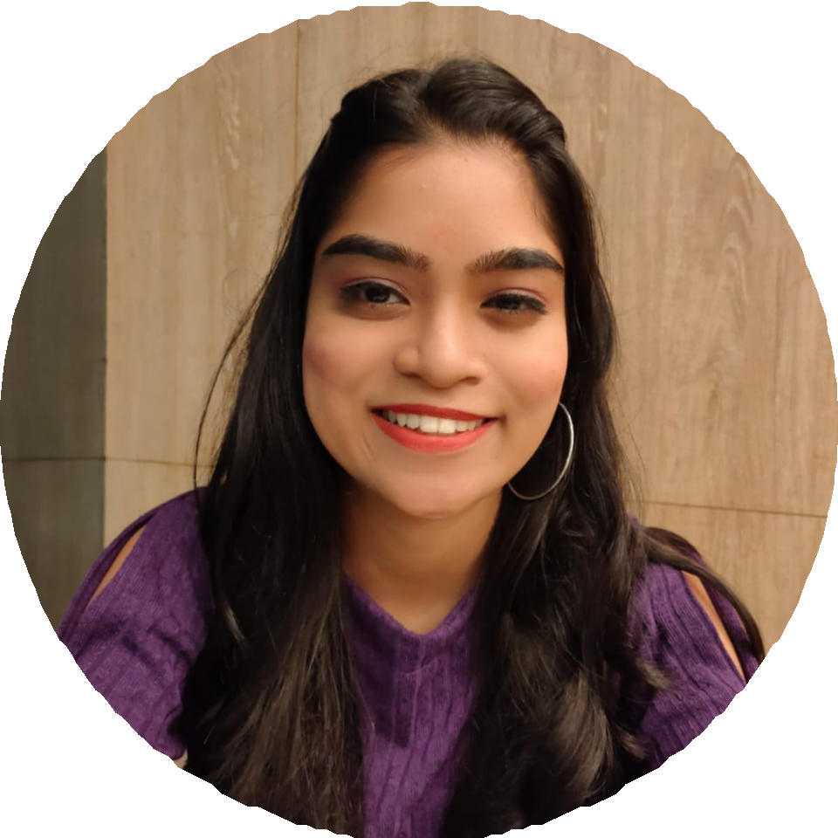

# PROFILE

Looking forward for individual

opportunity and

professional growth. I consider my self a responsible and

orderly person.

I am looking foward for new work

experience.

# CONTACT ME

8652042597/8850558167

[mhatresuhruda6@gmail.com](mailto:mhatresuhruda6@gmail.com)

Plot No 168, C-23,

Kiran Society,

Gorai-2, Borivali (West), Mumbai- 400091.

Linkedin Profile:

https://www.linked in.com/in/

suhruda-mhatre- 9b9883241

# EDUCATION

## MUMBAI UNIVERSITY

*Done my Post Graduation in M.com with specialization in Accounts and secured 64.50% (2020-2022).*

## SATAHYE COLLEGE

*Completed my Graduation in B.com*

*from Mumbai University and secured 7.68 CGPI (2017-2020).*

*Done H.S.C in Commerce background from Maharashtra Board and got 76% (2016-2017).*

## NALANDA ACADEMY

*Done S.S.C from Maharashtra Board and got 83.20% (2014-2015).*

# LANGUAGE

English Marathi Hindi

# WORK EXPERIENCE

## DATAMATICS BUSINESS SOLUTIONS LTD.

Worked as an Intern in Canada

Taxation and prepared T1 Tax Return (4 Months).

**PERSONAL PROFILE**

Father Name: Sudhakar Date of Birth: 16th

September 1999 Martial Status: Unmarried

Gender: Female Religion: Hindu

Nationality: Indian

 **COMPUTER SKILLS**

Course on Computer Concept (CCC) for 3 months.

Advance MS-Excel for 3 months. Advance Tally Prime.

English Typing 30 WPM and 40 WPM.

Marathi Typing 30 WPM.

 **ADDITIONAL INFORMATION**

## INVACT METAVERSITY

Currently pursuing Invact Finance

Training course, focusing on Financial Models, Income Statements, Pivot

Tables, Dashboards and other financial concepts. Enrolled since June 2023,

actively engaged in ongoing projects.

 **STRENGTH**

Self-Motivating Communication Adaptivity

Time Management Decision Making

 **DECLERATION**

I do hereby declare that the statements made in this document are true to the best of my knowledge and belief.